

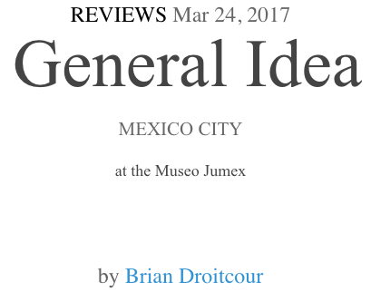

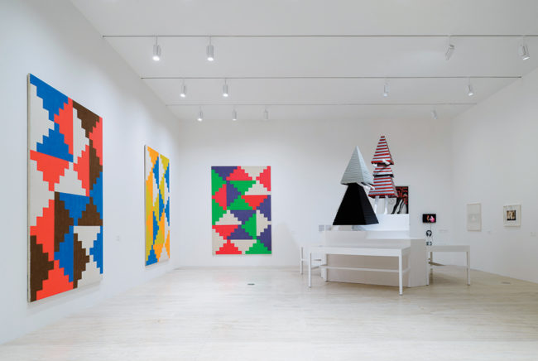
View of the exhibition “General Idea: Broken Time,” 2017, at the Museo Jumex.

Gay nightlife gave rise to the drag ball as an underground simulation of female celebrity. General Idea, the Toronto-based art collective, did something similar with its Miss General Idea pageant, though only one of the four winners of the annual event, held in Toronto from 1968 to 1971, was a man; the competition wasn’t about gender so much as it was about art as a system for producing value and fame. Playing on a monitor at the entrance to the retrospective exhibition “General Idea: Broken Time” at the Museo Jumex, Pilot (1977), which the group made for Ontario public television, is a thirty-minute deadpan documentary on the pageant that provides an introduction to the collective’s interests and sensibilities.

“Miss General Idea is basically this: an ideal framing device for arresting attention without throwing away the key,” one of the group’s members intones. Later, as a succession of still images shows photo cutouts of the pageant winners in various indoor and outdoor settings, we hear a woman saying: “Miss General Idea may not be beautiful; her title grants her the framework within which glamour settles like dust.” Aspiring to become famous artists, the boys of General Idea were fascinated by the architecture of notoriety and found a hybrid method that suited their ends. Duchamp appropriated objects; Warhol, images. General Idea stole cultural platforms, producing an illegal gay marriage of Pop appropriation and parody.
But General Idea was a threesome—AA Bronson, Felix Partz, and Jorge Zontal—and their approach, correspondingly, incorporated a third strategy: the infiltration of available communications networks to make them work for the collective’s own purposes. The artists used this tactic throughout their work, from their early mail-art projects—which included instructions for Fluxus-like actions distributed through chain letters, as well as solicitations for applicants to and spectators at Miss General Idea pageants—to Imagevirus (1987–1994), their transformation of Robert Indiana’s 1966 love logo into an aids one that they distributed via magazine ads, billboards, and posters, as well as T-shirts, scarves, and other paraphernalia. Imagevirus dominated the final years of General Idea, starting before Zontal’s and Partz’s HIV diagnoses and lasting until their deaths.

General Idea was constantly testing and contesting the relations among different frameworks and among the objects that garnered attention through them. Often a concept that began as an object became a framework and vice versa. The group was drawn to formats where that ambiguity was inherent: Miss General Idea is both the pageant and its winner, “mail art” signifies both a network and a thing that travels through that network. FILE Megazine, a DIY periodical that General Idea published from 1972 to 1989, was not only a means of documenting and distributing the collective’s work, but also a hub where artists could meet like-minded peers. A vitrine of FILE issues at Jumex included one open to a page with “image requests” (e.g., “Ed the Shed / Requests images of legs from the knees & of red shoes”)—a slow, collaborative counterpart to the online research artists do now.

As “General Idea: Broken Time” unfolded in the museum’s circular warren of galleries, concepts and motifs mutated and developed. This evolution was most visible in works involving the ziggurat form. In the first gallery, which highlighted mail-art projects and performance documentation, one vitrine contained a sheet of graph paper with multiple drawings of interlocking ziggurats. Each ziggurat occupies sixteen squares of the graph paper; the base spans seven cells and the rows taper to a single cell at the top. The ziggurats fit together in rectangles animated by the effect of various staggered, stepwise movements.
The walls of the next gallery were lined with “Ziggurat Paintings” (1968–69), which realize such compositions in bold pigments, some of them Day-Glo, teasing the eye as much as the funky symmetry of the overall pattern. Each painting in the series is dedicated to a Miss General Idea contestant, and on a platform in the gallery’s center, two mannequins wore ziggurat-shaped dresses made of Venetian blinds—a concept for the 1984 Miss General Idea pageant, which the group began releasing ephemera about in the 1970s as a sort of future event that had come to a dramatic end, as the pavilion that supposedly housed it had burned down during the event. The following gallery featured other designs for this fictitious pageant, including a seating chart for 1,984 audience members, drawn as a floor plan of 124 interlocking ziggurats, and photographs of a wooden ziggurat engulfed in flames.
Agustín Pérez Rubio—instigator of the exhibition and curator at the Museo de Arte de Latinoamerica Buenos Aires, where the show is on view through June 26—conceived the title “Broken Time” because, as he argues in a catalogue essay, time is the primary parameter for experiencing General Idea’s work. At first blush the conceit sounds specious: doesn’t physical distance matter just as much as temporality when it comes to measuring the journeys of the group’s images and ideas by means of chain letters, Telex transmissions, and television broadcasts? But the layout of the Jumex installation was subtly persuasive, as it revealed how concepts gradually accumulated layers, and how works created a decade or more apart mutually enhance each other’s meaning. Even at the entrance, the installation One Year of AZT (1991), its rows of oversize styrene pills serving as a calendar of a life evenly meted out in retroviral drugs, clashed productively with the screwball timeline of Pilot, which intersperses images of past winners of the Miss General Idea pageant while promoting the fictional future edition of it.

So many writers have discussed General Idea’s involvement in the AIDS crisis as both activists and victims that it’s virtually a critical cliché. What about balancing such retrospective closure with a realization that General Idea incorporated a rebeginning into the end of every work? They were obsessed with recording and rerecording their actions and transmissions, producing archives while the works were still live. In their hands, the ziggurat, usually associated with mausoleums and death, became a brightly generative form. In the video Shut the Fuck Up (1984), which documents a performance in Zurich while also providing a petulant rant about the mass media’s distortion of the intent of contemporary art, Zontal says: “We don’t want to destroy television. We want to stretch it, until it loses shape.” They did the same thing with time. Like any artists with ambitions of fame, they saw death coming, and lived their lives so as to outlast it.

