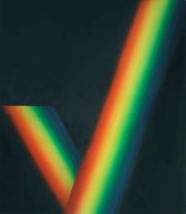
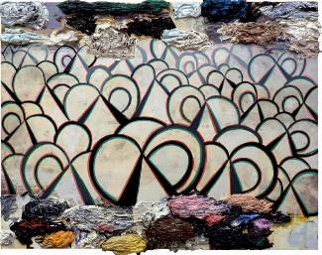
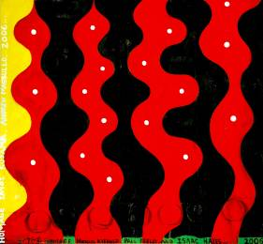
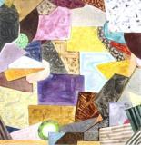
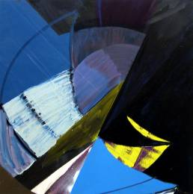

Abstract
December 2, 2006 - January 6, 2007

NOVEMBER 10, 2006: NEW YORK -- Mitchell-Innes & Nash will present a group exhibition of abstract painting in its Chelsea space from December 2, 2006 through January 6, 2007. The exhibition includes paintings by five artists whose work is devoted to issues of abstraction. The show brings to light the popularity of abstract painting among artists at a time when figurative and representational art have become so prevalent.
Chris Martin, one of the artists in the exhibition, articulated this paradox in a recent article: “Abstraction no longer exists as a movement and no longer leads any avant-garde. The distinctions between abstraction and other art have become increasingly meaningless. Abstract painting is dead. That’s why it has become so interesting again.”* The Mitchell-Innes & Nash exhibition presents diverse approaches to abstract painting and includes works by the following five artists:

- Phillip Allen - Allen is represented by The Approach Gallery (London); his solo shows include Kerlin gallery, Dublin in 2005 and P.S.1 in Long Island City, New York, in 2003

- Alison Fox - A 2005 MFA graduate from Hunter College, Fox had her first solo shows last year at ATM gallery in New York and at Marc Selwyn Fine Art in Los Angeles

- Alex Kwartler - Represented by John Connelly Presents, Kwartler was included in last year’s The Painted World, at P.S.1 in Long Island City, New York.

- Chris Martin - A former performance artist, Martin recently had a solo show at Sideshow in Brooklyn. Included last year in The Painted World, at P.S.1 in Long Island City, New York and a group show at Feature Inc., Martin is represented by Daniel Weinberg gallery, in Los Angeles;

- Rebecca Morris - Represented by Galerie Barbara Weiss (Berlin); the Renaissance Society in Chicago presented a ten-year retrospective of Morris’ work in 2005

Listing Information:
Mitchell-Innes & Nash Chelsea is located at 534 West 26th Street.
Gallery Hours: Tues-Sat, 10am – 6pm T: (212) 744-7400 www.miandn.com
Opening reception will be held at Mitchell-Innes & Nash Chelsea on Friday, December 1, from 6 – 8 pm
Press Information: Stacy Bolton Communications T: 212.721.5350 E: Emily@StacyBolton.com

CAPTIONS, left to right: Phillip Allen, Untitled, oil on board, 14.2 x 18.1 in., 2006; Alison Fox, Midnight, oil on canvas, 24 x 24 in., 2006; Alex Kwartler, Untitled (Check), oil on canvas, 23 x 20 in., 2006; Chris Martin, Isaac Hayes Painting, oil and mixed media on canvas,
59 x 64 in., 2006; Rebecca Morris, Untitled 06-06, oil on canvas, 82 x 80 in., 2006. All courtesy Mitchell-Innes & Nash.

* The Brooklyn Rail, April 2003

